Assignment 6

Q5. Write a query to list the number of jobs available in the employees table.

Ans

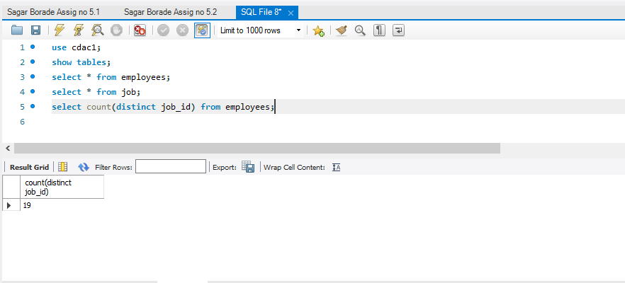

Q6. Write a query to get the total salaries payable to employees.

Ans

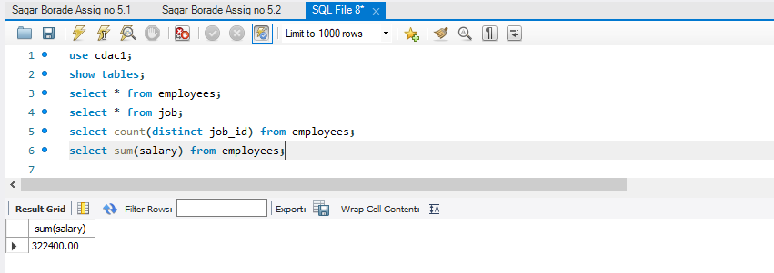

Q7. Write a query to get the average salary and number of employees working in the department 40.

Ans

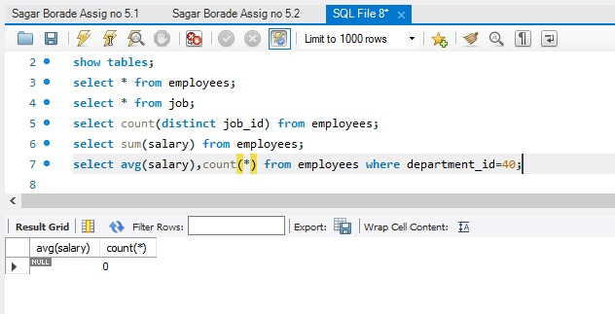

Q8. Write a query to get the department ID and the total salary payable in each department.

Ans

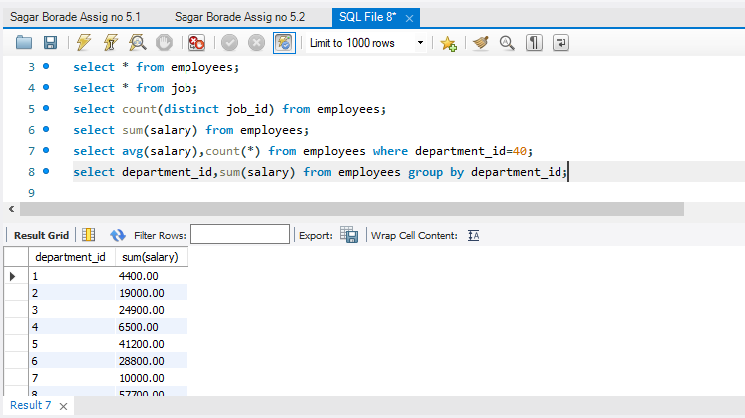

Q9. Write a query to get the total salary, maximum, minimum, average salary of employees (dept id

wise), for department ID 60 only.

Ans

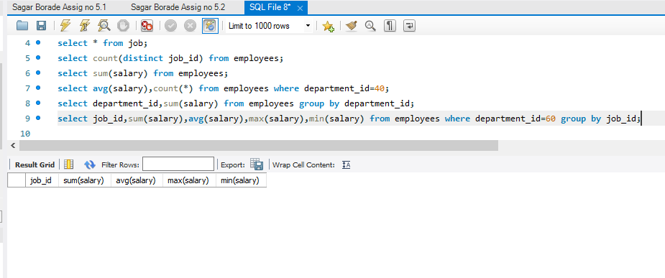Q10. Write a query to get the average salary for all departments employing more than 10 employees.

Ans

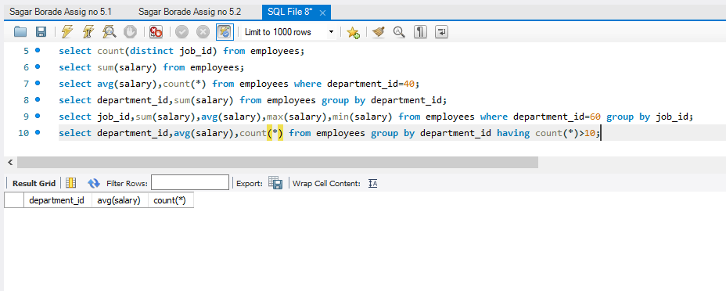

Q11. Write a query to find the names (first_name, last_name) and the salaries of the employees who

have a higher salary than the employee whose last_name.

Ans

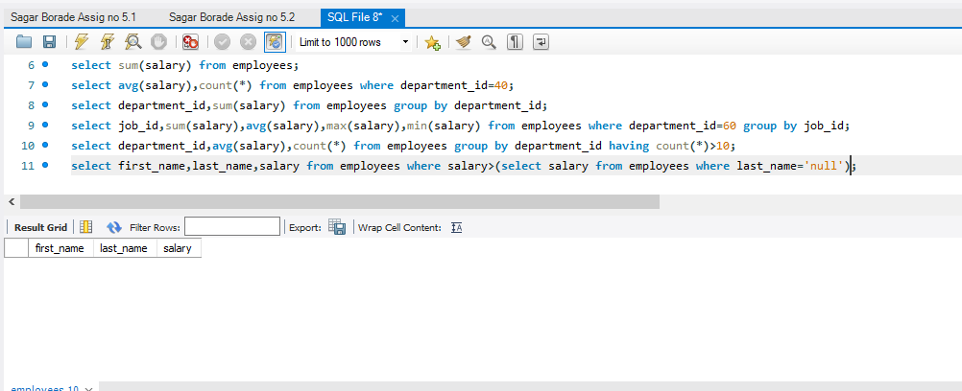

Q12. Write a query to find the names (first_name, last_name) of the employees who are managers.

Ans

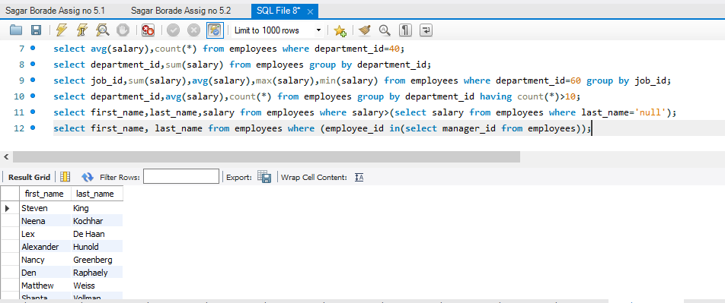

Q13. Write a query to find the names (first_name, last_name), the salary of the employees whose salary is greater than the average salary.

Ans

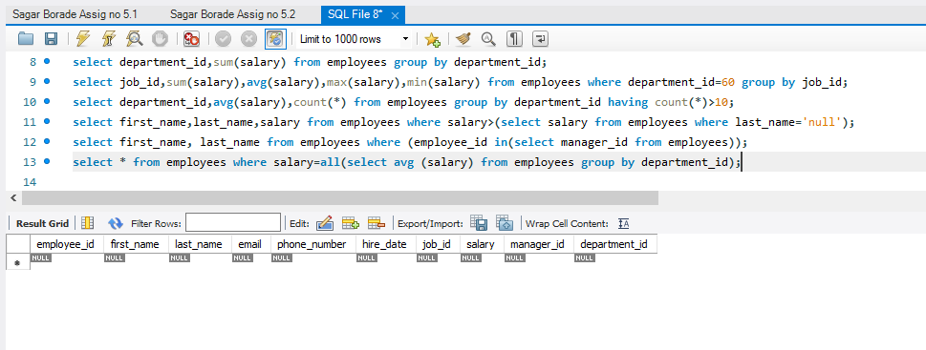

Q14. Write a query to find the names (first_name, last_name), the salary of the employees who earn

more than the average salary and who works in any of the IT departments.

Ans

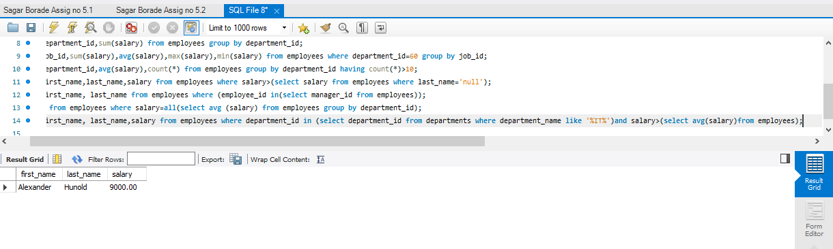

Q15. Write a query to find the names (first_name, last_name) and salary of the employees who earn a salary that is higher than the salary of all the Shipping Clerk (JOB_ID = &#39;SH_CLERK&#39;). Sort the results of the salary of the lowest to highest.

Ans

